Mars Rover
Send Feedback

We will be using NASA API to build a simple web page - https://api.nasa.gov/api.html#MarsPhotos

The web page takes date as input using a datepicker. You can use jQuery UI for datepicker. After submitting the date, the images for that date get displayed on the page.

Do proper error handling on the web page as well, like an alert should be shown when the input is empty.

The web page looks like this -
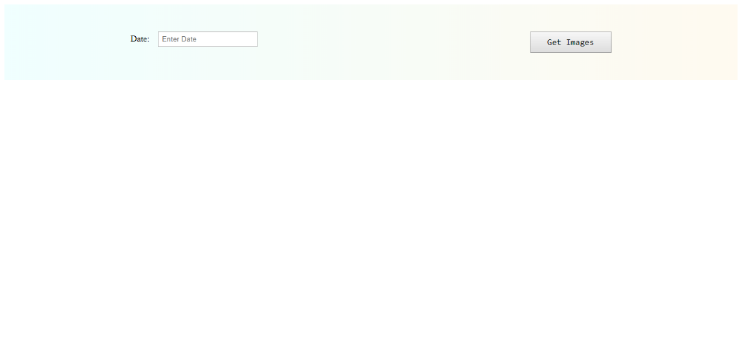

On entering the date, the web page would look like this -
